Name : Saurabh Sanjay Jadhav

Topic : Ansible playbook.

Assignment no : 12

1. Create group of servers in hosts file.

1. Create playbook1.yaml

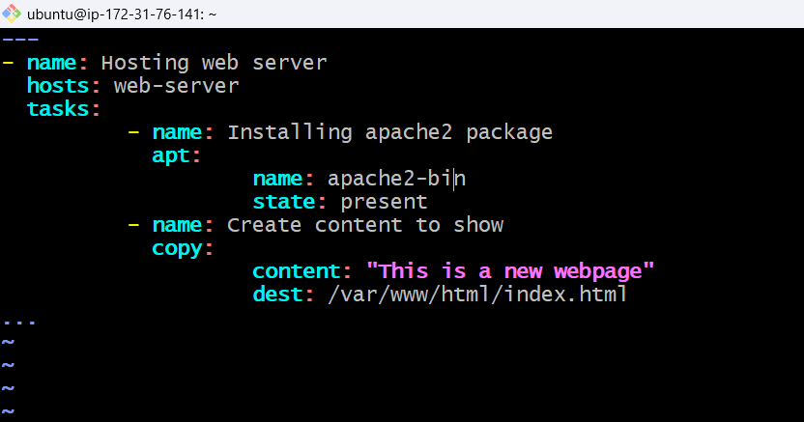

1. Run playbook file.

1. Successfully able to access the web server.

1. Create Playbook for global variables.

Run ansible playbook command with global variables.

1. Create playbook for playbook variable.



